Question related to copy – paste
Model: test group widget1 with new diagram
I would like to copy only part of the model (only stock and flows)
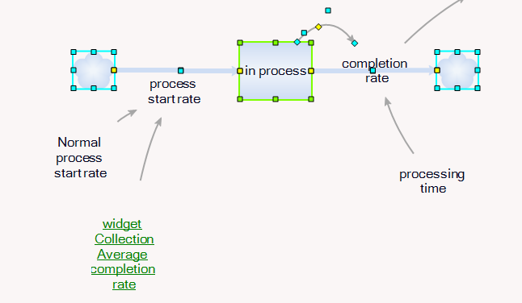

Paste in new diagram (widget-overview) looks like this:
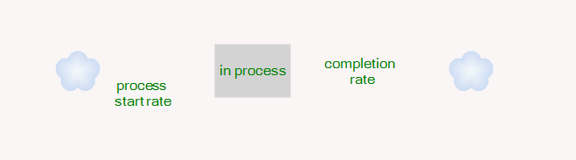

Why are the flows not represented?

