Project title: Assessment of an Appropriate Health Care Supply in Switzerland: the Example of Coronary Heart Disease

- Research topic and objectives
The Swiss health system is good, but expensive (OECD 2011). Costs are rising, in the inpatient as well as in the outpatient sector. The discussion about how to curb rising costs without compromising quality of health care is controversial. This controversy pertains to the definition of an appropriate supply and to the design of adequate policy interventions.
The motivation for these interventions is rooted in the observation that physicians’ decisions in addition to purely medical reasons also include economic considerations. This observation is reflected in a broad literature on supply-induced demand (see e.g. Breyer, Zweifel, and Kifmann 2013; Cutler et al. 2013; Skinner 2011). However, clear criteria for an appropriate supply with medical services are missing and cannot be derived from existing studies about health care utilization.
Any policy intervention has to rely on the analysis of health care demand and/or empirical evidence including monitoring, analysis and predictive models. For this analysis, three types of methodological approaches are distinguished: supply projections or trend models, demand-based approaches and needs-based approaches (SAMW 2016). Demand-based approaches include the analysis of the utilization of medical services, while needs-based approaches also changes with regard to prevalence and incidence of diseases and risk factors. However, needs-based models are deemed to be complex and challenging. For this reason only few attempts have been made to date to adopt this approach.
The objective of this study is to provide a needs-based analysis of a relevant health problem in Switzerland. It is envisaged to develop a prototype simulation model of the burden of disease of coronary heart disease (Acute Coronary Syndrome ACS) in a specific population and as a consequence the amount of medical services delivered for diagnosis and treatment of this disease. For this purpose a patient flow perspective is adopted following the stages from the onset of symptoms and diagnostic interventions to treatment and follow-up. The time horizon of the model is 2000 – 2030.
The exemplary case of coronary heart disease is chosen for two reasons: first, cardiovascular diseases are the leading causes of morbidity and mortality in Switzerland (Federal Statistical Office 2017); second, only a limited number of different medical specializations are involved in diagnosis and treatment. As a consequence the patient flow and the model structure are relatively simple and transparent. Moreover, a number of Guidelines have been issued in recent years by the European Society of Cardiology (ESC) as well as by other societies and organizations, aiming at assisting physicians in selecting appropriate management strategies for an individual patient.
It is envisaged to study the effect of medical practice variation on the amount of medical services. In particular, it is intended to analyse what happens if a potential overuse of certain diagnostic and/or therapeutic interventions is avoided. A recent study by (Chmiel et al, 2015) found evidence of insufficient guideline adherence and a potential overuse of possibly harmful and inappropriate diagnostic interventions in non-emergency situations. These findings suggest that practice variation regarding diagnostic and therapeutic interventions, in particular in non-emergency cases and in the follow-up of an acute situation, play a major role for the amount of medical services that are provided.
This model does not address the interrelations between supply and demand of medical services and is focused purely on the demand side. In future, however, it is intended to include the supply side endogenously in the model.

- Research questions
Against this background three research questions are formulated:
- What is the amount of medical services in the Swiss population at different stages along the treatment chain, based on current evidence-based medical practice?
- Which changes in the amount of medical services are to be expected as a consequence of a variation in population, risk factors and medical practice?
- What contribution can such a simulation model provide for health care planning and the discussion of appropriate medical care?
- Model description
The model describes a potential transition from a state without diagnosed ACS to a state with diagnosed ACS. As a consequence the model consists of two parts which refer a) to the onset of symptoms, including diagnosis and treatment of ACS and b) to a situation with a chronic coronary heart disease with follow-up treatment and potential recurrent events (Figure 1).
People without diagnosed ACS may present with symptoms of ACS, undergo diagnostic interventions and are potentially diagnosed with ACS. The diagnostic interventions consist of three potential stages: anamnesis by a general practitioner (GP), non-invasive diagnosis (cardiologist and/or general practitioner) or diagnosis in a hospital (invasive, coronary angiography). The result of the diagnosis in each step may be positive (with admission to medical and/or surgical treatment), uncertain (with referral to further diagnostic intervention) or negative (flow back to population). Diagnostic interventions start when a person presents with symptoms of ACS (chest pain). Patients with acute myocardial infarction (MI) presenting at an emergency department are treated separately.
Diagnostic as well as therapeutic interventions depend on the risk category of the patients. These risk categories include non-modifiable aspects such as gender and age, and modifiable aspects such as hypertension and smoking (reference). Score risk charts to calculate the individual cardiovascular risk are well-established (e.g. ESC score risk chart) and have also been adapted to the Swiss population (AGLA score risk chart). For our simulation model two risk categories will be distinguished, which correspond to a low (normal) risk level and a high risk level. Risk is calculated using gender, age and hypertension. Changes in the aforementioned risk factors due to aging as well as due to primary prevention are taken into consideration. Prevention is considered as a variable degree of adherence to hypertension control programmes.
Population data are available for 1900 to 2030 (Swiss population reference scenarios), including detailed age- and gender-specific mortality rates for each annual cohort. Prevalence of hypertension (age, gender) for the Swiss population is documented in by the Swiss Health Observatory, while for the incidence of hypertension data from Canada will be used (Robitaille et al. 2012). Data for the onset of chest pain symptoms are available in (Ruigomez 2005). Transfer coefficients describing fractions of negative, positive or uncertain diagnoses will be derived from Swiss health insurer’s registries. This data retrieval is still ongoing. In addition to these data information derived from guidelines for the management of coronary heart disease of the European Society of Cardiology as well as data from selected cardiologists will be used (Guidelines on the Management of Stable Coronary Artery Disease 2013). Potential overuse of (invasive) diagnostic interventions is derived from (Chmiel et al. 2015).

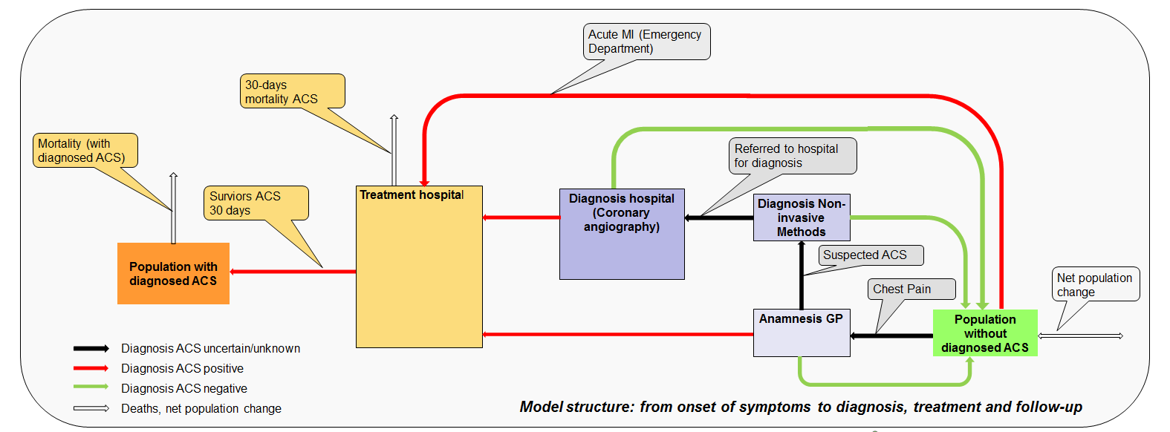
Figure 1: Model structure: from onset of symptoms to diagnosis, treatment and follow-up.
With regard to treatment two different options are considered: invasive treatment including percutaneous coronary interventions (PCI) and coronary artery bypass grafting (CABG), and treatment based on medication only. Two reasons speak for this assumption: the outcomes of both interventions (PCI, CABG) as well as the costs are in the same order of magnitude (Fox et al. 2010), and follow-up as well as frequency of recurrent events are similar in both cases. Patients with a diagnosed ACS are treated periodically during follow-up and may undergo recurrent events (Smolina et al. 2012). The amount of periodic treatments will be derived from insurer’s data. The total amount of medical services depends on the number of diagnostic and therapeutic interventions at different stages of the treatment chain.
- Model structure
The fundamental model structure is in a highly simplified way shown in Figure 2. Incidence rates CHD involve diagnosis and treatment (see above). All flow rates are specified according to age and gender. Net migration is not shown here, but will be included.
From a modelling point of view it is the question how to address this problem appropriately with Ventity.
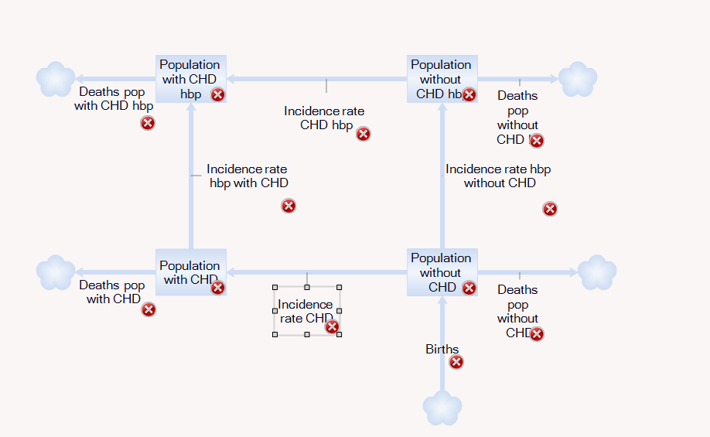
Figure 2: Simplified model structure

References
“2013 ESC Guidelines on the Management of Stable Coronary Artery Disease: The Task Force on the Management of Stable Coronary Artery Disease of the European Society of Cardiology.” 2013. European Heart Journal 34 (38): 2949–3003. doi:10.1093/eurheartj/eht296.
Breyer, Friedrich, Peter Zweifel, and Mathias Kifmann. 2013. Gesundheitsökonomik. 6th ed. Berlin Heidelberg: Springer Gabler.
Chmiel, Corinne, Oliver Reich, Andri Signorell, Ryan Tandjung, Thomas Rosemann, and Oliver Senn. 2015. “Appropriateness of Diagnostic Coronary Angiography as a Measure of Cardiac Ischemia Testing in Non-Emergency Patients-a Retrospective Cross-Sectional Analysis.” PloS One 10 (2). http://dx.plos.org/10.1371/journal.pone.0117172.
Cutler, David, Jonathan Skinner, Ariel Dora Stern, and David Wennberg. 2013. “Physician Beliefs and Patient Preferences: A New Look at Regional Variation in Health Care Spending.” National Bureau of Economic Research. http://www.nber.org/papers/w19320.
Federal Statistical Office. 2017. “Causes of Death in 2014.” Accessed March 13. https://www.bfs.admin.ch/bfs/de/home/statistiken/gesundheit.assetdetail.40503.html.
Fox, K. A. A., K. F. Carruthers, D. R. Dunbar, C. Graham, J. R. Manning, H. De Raedt, I. Buysschaert, D. Lambrechts, and F. Van de Werf. 2010. “Underestimated and under-Recognized: The Late Consequences of Acute Coronary Syndrome (GRACE UK-Belgian Study).” European Heart Journal 31 (22): 2755–64. doi:10.1093/eurheartj/ehq326.
OECD. 2011. “OECD Reviews of Health Systems: Switzerland 2011.” OECD Publishing. http://dx.doi.org/10.1787/9789264120914-en.
Robitaille, Cynthia, Sulan Dai, Chris Waters, Lidia Loukine, Christina Bancej, Susan Quach, Joellyn Ellison, et al. 2012. “Diagnosed Hypertension in Canada: Incidence, Prevalence and Associated Mortality.” Canadian Medical Association Journal 184 (1): E49–E56.
Ruigomez, A. 2005. “Chest Pain in General Practice: Incidence, Comorbidity and Mortality.” Family Practice 23 (2): 167–74. doi:10.1093/fampra/cmi124.
SAMW. 2016. “Steuerung Der Anzahl Und Der Verteilung von Ärztinnen Und Ärzten.” Accessed December 6. http://www.samw.ch/dam/jcr:0f4d6172-5329-4e87-ad07-bdef13af4e49/SAMW_Comms_AerzteZahl_16_D_fWeb-kl.pdf.
Skinner, Jonathan. 2011. “Causes and Consequences of Regional Variations in Health Care." In Handbook of Health Economics, 2:45–93. Elsevier. http://linkinghub.elsevier.com/retrieve/pii/B9780444535924000025.
Smolina, Kate, F. Lucy Wright, Mike Rayner, and Michael J. Goldacre. 2012. “Long-Term Survival and Recurrence After Acute Myocardial Infarction in England, 2004 to 2010.” Circulation: Cardiovascular Quality and Outcomes 5 (4): 532–40. doi:10.1161/CIRCOUTCOMES.111.964700.

http://www.escardio.org/Education/Practice-Tools/CVD-prevention-toolbox/SCORE-Risk-Charts
https://www.agla.ch/risikoberechnung/esc-score
https://www.pxweb.bfs.admin.ch/Selection.aspx?px_language=fr&px_db=px-x-0102020300_101&px_tableid=px-x-0102020300_101\px-x-0102020300_101.px&px_type=PX
http://www.obsan.admin.ch/de/indikatoren/bluthochdruck

